Cafeteria Sales
Problem Statement:
Cafeterias often generate large volumes of sales data daily. However, this data is frequently underutilized, leading to missed opportunities in optimizing operations, and increasing profitability. The lack of systematic analysis makes it difficult for cafeteria management to identify trends, forecast demand, reduce waste, or improve revenue.
In this project, we are interested in analyzing the content of Cafeteria that lists 10000 transactions over a period of one year (1/1/2023 to 31/12/2023). This project aims to analyze historical sales data from a cafeteria to uncover actionable insights that can help improve business performance. Key focus areas include identifying peak sales periods, best-selling items and revenue trends.
Tasks:
- Perform Data Cleaning on the sales data
- Identify and handle missing values in key fields such as transaction date, item, quantity, or price per unit
- Correct incorrect or inconsistent entries (entries containing UNKNOWN, ERROR)
- Convert data types to appropriate formats (e.g., integers for quantity, floats for price, datetime for timestamp).
- Remove duplicate records (if any), that may arise due to system glitches or repeated data entries
- Find correlation, if any between data columns

Exploratory Data Analysis:
1. Correlation of data
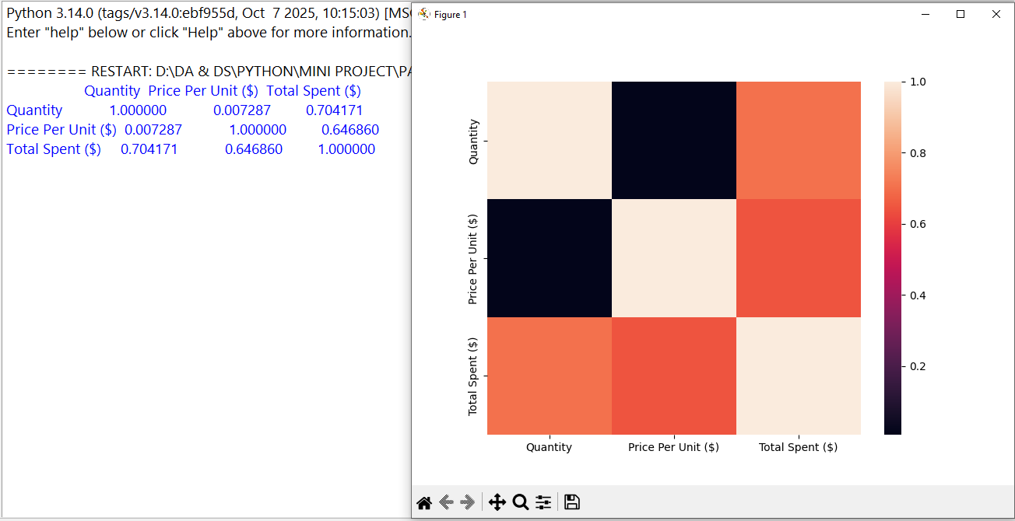
- Price per unit vs Total spent 2. Quantity vs Total spent
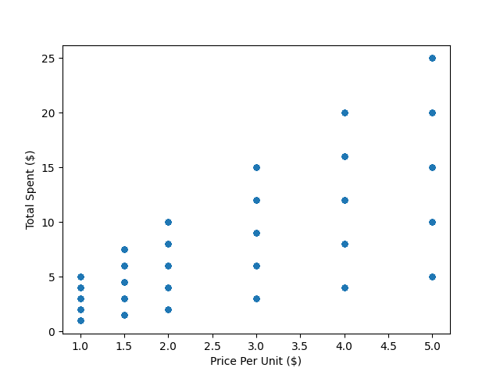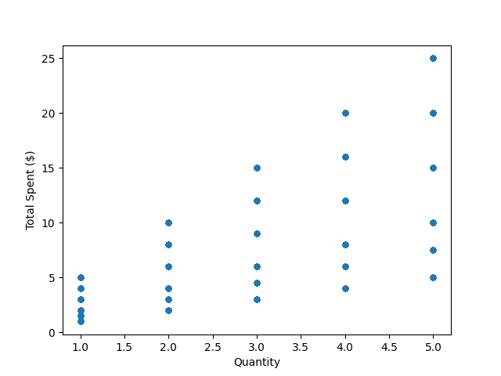
3. Monthly wise sales 4. Quantity data distribution
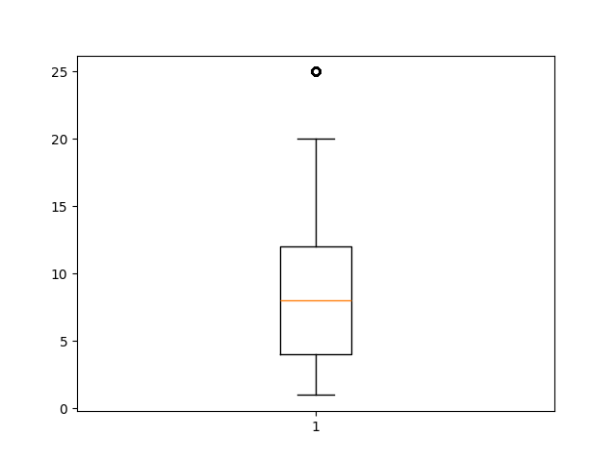
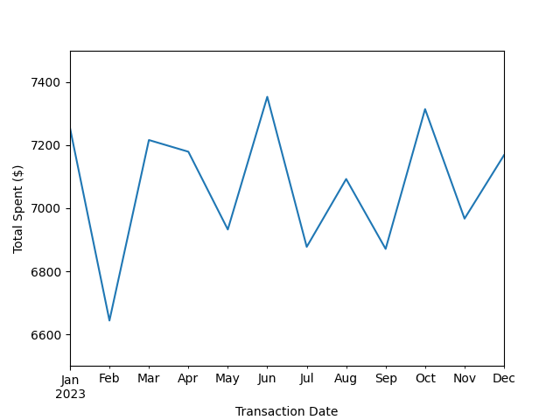
5. Item wise Total revenue 6. Total spent data distribution
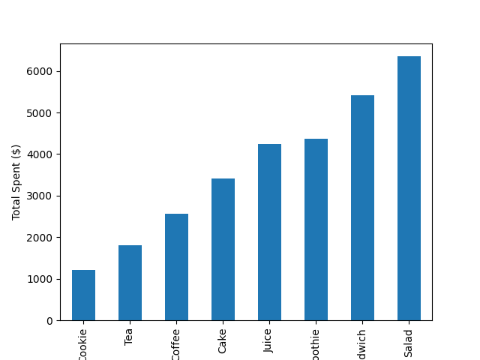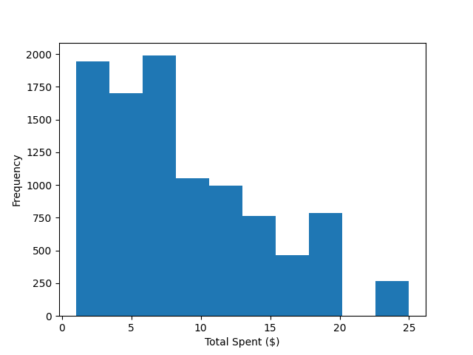

Insights:
From above Exploratory Data Analysis here are the insights on the revenue of the cafe
- Monthly revenue fluctuates between $6,700 and $7,400, showing stable but non-growing performance.
- February shows the lowest revenue, indicating a seasonal dip or weak customer activity.
- June and October show revenue peaks, suggesting higher demand during these months.
- The cafe has consistent regular customers but lacks strong growth momentum.
- Salad is the top contributor followed by Sandwich and Smoothie
- Healthy and fresh items like Salad, Smoothie, Sandwich, and Juice are the cafe core revenue drivers, while low-priced quick items are under-performing. Customers prefer quick, fresh, value-for-money items.
- The cafe has price flexibility. Small price increases on popular items are unlikely to hurt sales.
- Majority of customers spend $7 – $12 per order. Few high-spending customers above $15 per order appear as outliers.
Strategies to Improve Business:
Here are some strategies to improve sales and revenue of the café in future
- Since Salad, Sandwich, Smoothie, and Juice generate most revenue, introduce some different versions like Protein Salad, Classic Grilled Sandwich which also attracts health concern customers. Also introduce combos like Salad + Smoothie, Sandwich + Juice so that change to increase order value.
- Cookie and Tea have low revenue contribution try to introduce new and trending flavors in cookies mostly to attract children. Also add Tea + Cookie combo a usually common buy for customers.
- Ensure consistent stock for Juice, Salad ingredients, Sandwich supplies. Reduce over-stocking low-demand items like Cookies to avoid wastage.
- Provide coupons or to regular customers also provide free samples on low selling products like cookies, male sure the size of the sample product to be small just to give them the taste and interest on the item.
Conclusion:
Overall, the insights from the café sales analysis clearly highlight the key revenue generators, customer preferences, and areas needing improvement. The recommended strategies provide actionable steps to enhance items performance, boost high-value items, and increase overall customer spending. By applying these data-driven decisions, the café can achieve sustainable revenue growth and stronger operational efficiency.

